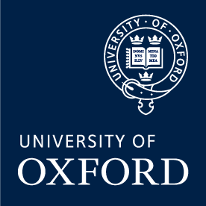
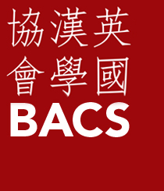

BACS Annual Conference
British Association for Chinese Studies
University of Oxford
Co-hosted by Asian Studies Centre at St Antony’s College, Oxford School of Global and Area Studies (OSGA), and the Oxford China Centre.
31st August – 1st September 2022
BACS is pleased to announce that the 2022 Conference of the British Association of Chinese Studies will be held in-person at St Antony’s College, University of Oxford.
Keynote Speakers
Frank Dikotter, Hong Kong University, China After Mao
Jieyu Liu, SOAS, Family Life in Urban China: A Three-Generation Portrait
The call for papers and panel proposals is now open!
To submit a proposal for a paper or a panel please send a word document to bacs@sant.ox.ac.uk
If you want to propose a paper, please put ‘PAPER’ in your email subject line. In your word document please give details of your name, email address and institutional affiliation (departmental and university). Please also state your paper title and provide a 250-word abstract.
If you want to propose a panel, please put ‘PANEL’ in your email subject line. In your word document please give the name, email address and institutional affiliation (departmental and university) of the organizer and each of the presenters. As panels are 90 minutes, it is recommended that panels have four presenters. Please include an abstract to describe the panel overall and then an abstract for each of the papers. Panels need to be diverse with respect to gender, ethnicity, and the career stage of the participants – please explain how your panel meets this diversity requirement in your submission.
Key dates
- Call for Papers: Now Open
- Deadline for submission of proposals (250 words): 3rd June 2022
- Notification of acceptance: June 2022
- Registration Opens: 24th June 2022
- Registration Closes: 5th August 2022
- Final Programme: early August 2022
- Conference dates: 31st August – 1st September 2022

Expected conference fees (including catering, refreshments and conference dinner)
 | BACS Members | Non-BACS-Members
Student/Unwaged | £52 | £65
Waged | £58 | £95

BACS members are eligible for a reduced conference registration fee.
How to become a BACS member or to renew your membership

